# Virtual Urgent Care – Patient MyChart Scheduling

Choose Virtual Urgent Care from the top or sidebar navigation

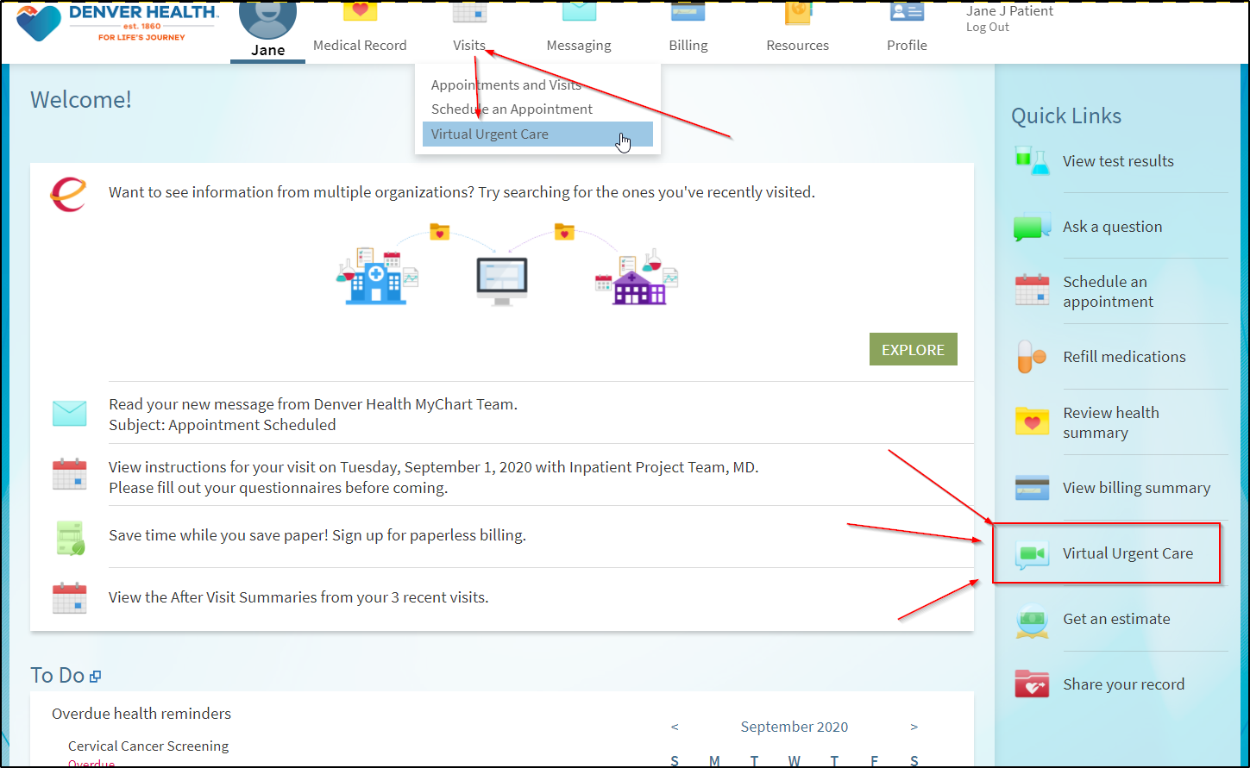

Confirm your location

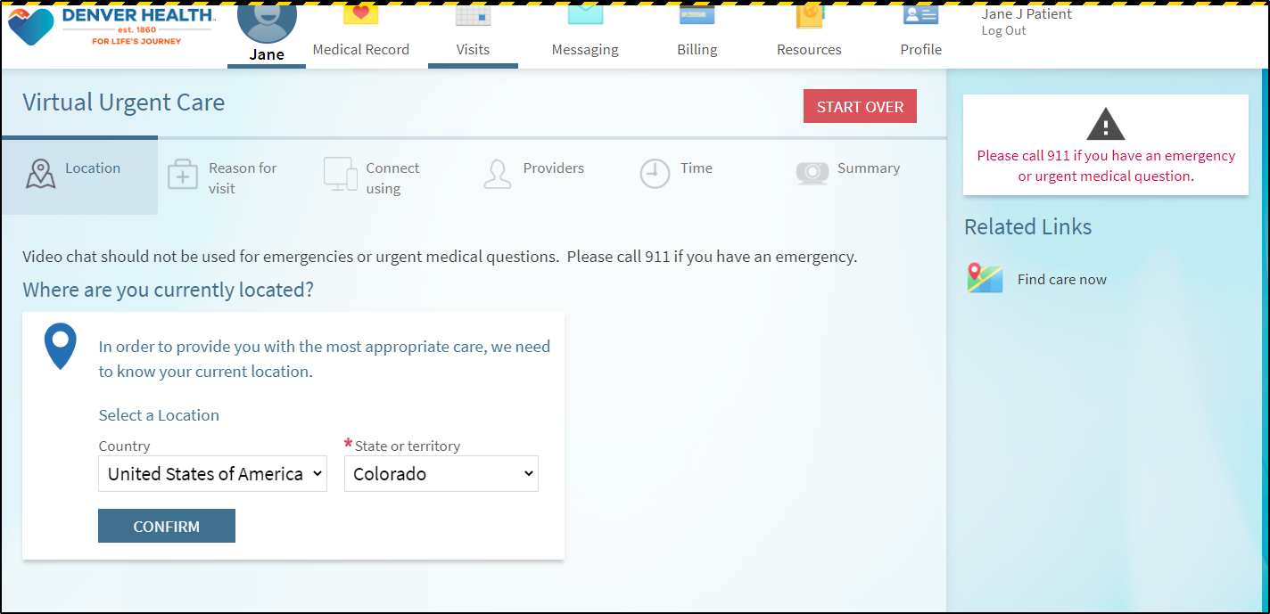

Select the reason for visit (What brings you here today?)

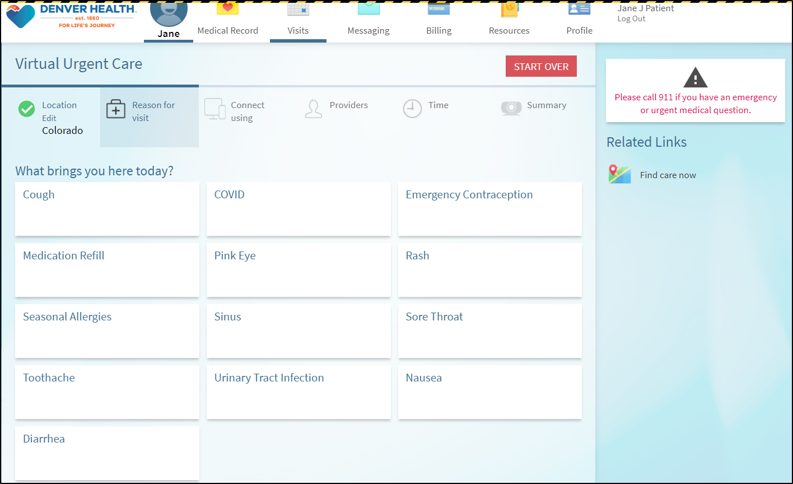

Patient is presented with connection test info/details on the video visit

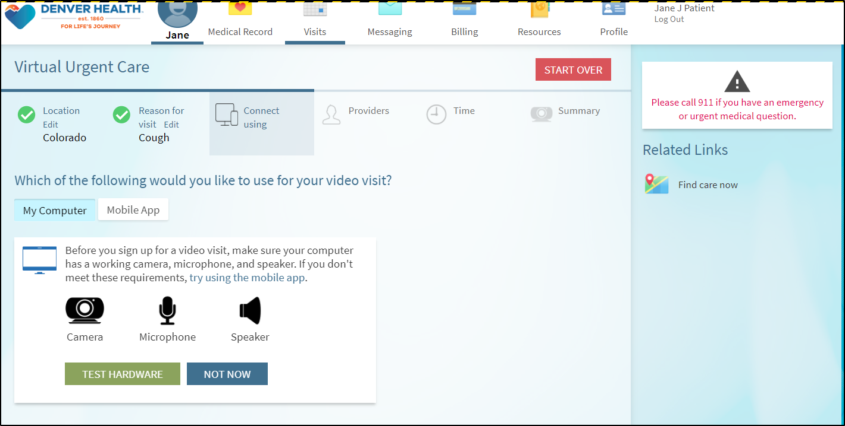

Patient is presented with first available time slot OR they can click the More Times button

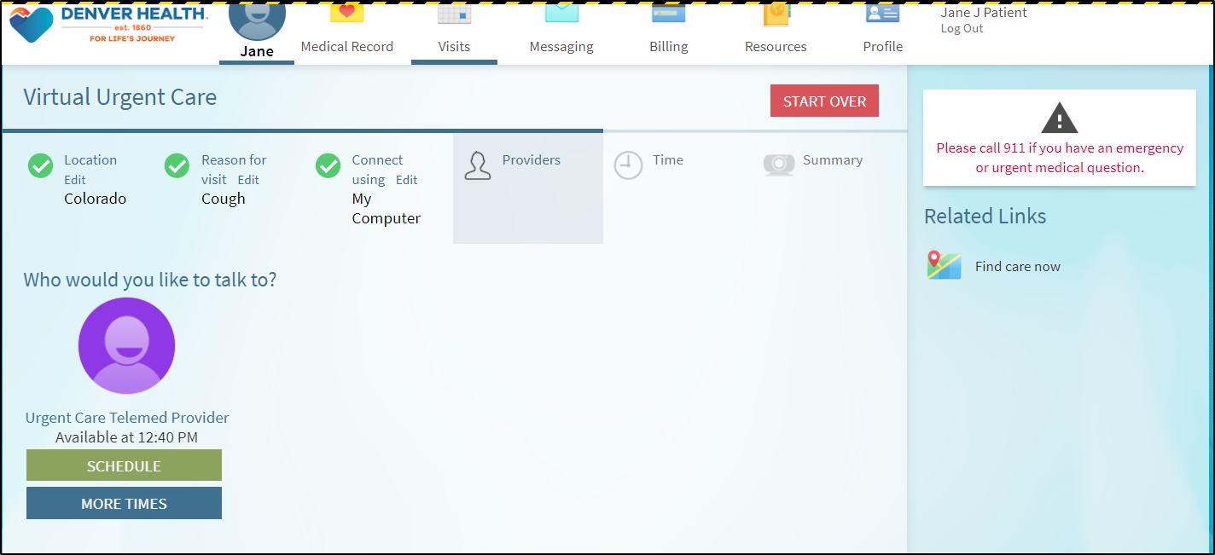

If they click the More Times button, they can see available times for today and tomorrow

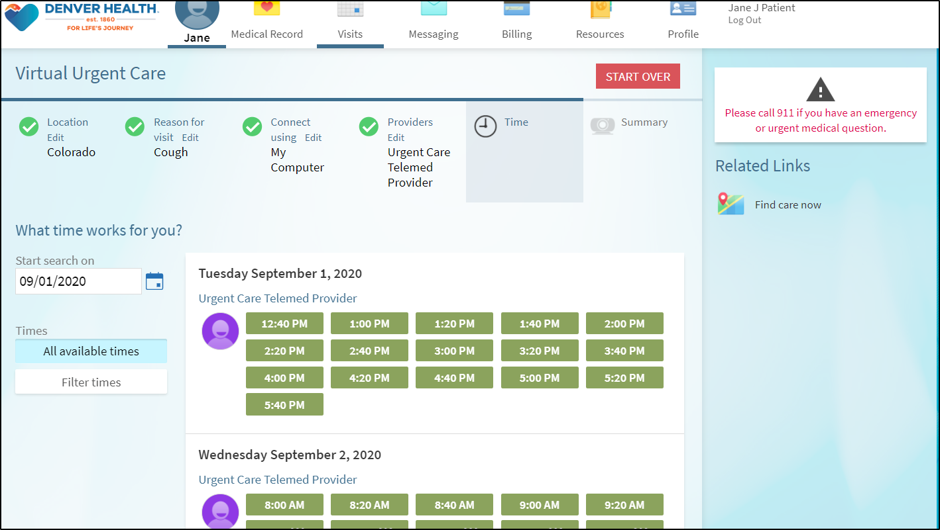

Patient types in a note about what they are wanting to be seen for or any concerns

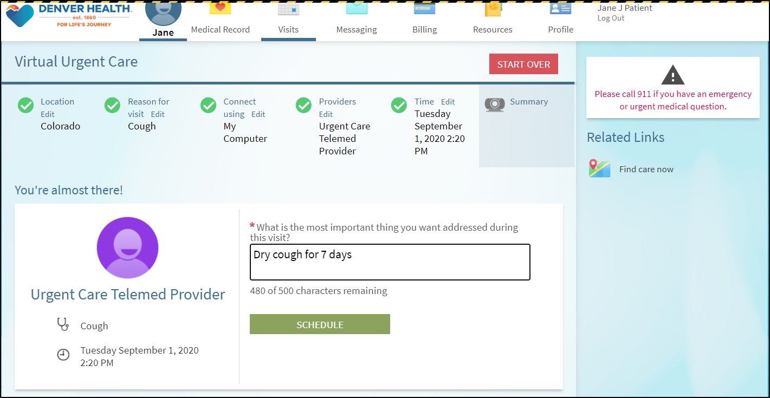

Confirmation page where they should complete the eCheck-In process  
(note: Confirm just cancels any automated text messages that would be sent out)

