Denver Health Contact Tracing Information and Instructions

When a staff member tests positive for COVID-19, their manager will contact them to perform a brief contact tracing interview. The goal is to identify any other staff members who may have had a high-risk exposure to the positive staff member. The interview usually takes about 10 minutes.

STEP 1. Manager receives email notification that one of their staff members has tested positive.

STEP 2. Manager contacts staff member who tested positive and collects the answers to the contact tracing questions in the table on page 2 of this document (note: manager answers #7).

STEP 3. In #6 of the Contact Tracing form, if you have:
- 5+ names: contact Infection Prevention to discuss at 2-BUGS (2-2847) before instructing your staff members to complete the survey.
- 1-4 names: instruct those staff members to complete the employee survey.
- 0 names: proceed to step 4 below.

For staff completing the employee survey for testing related to a high-risk exposure:
- Check both of the buttons below
- Enter the earliest date of exposure to the positive employee during the window from 2 days before symptom onset (or positive test if asymptomatic) to the first day of isolation from work. This is the date you recorded in #6 of the contact tracing form.
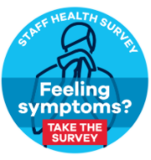
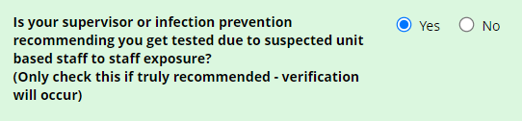
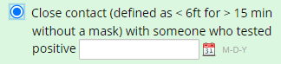

STEP 4. Email the completed table to InfectionPrevention@dhha.org.
On the subject line, put “Contact Tracing Form [Your Location/Unit] [Today’s Date]”

STEP 5. Optional: if you have questions, concerns or want to talk through your results with Infection Prevention, call 2-2847.

Frequently Asked Questions:

What is a high-risk exposure?
Being within 6 feet of a confirmed COVID-19 case for at least 15 minutes when both people are unmasked.

Can an exposed staff member work before they get tested?
Asymptomatic employees should work as usual.
Symptomatic employees should not work while waiting to get tested.
Please see Staff COVID-19 Exposure Guidance for more information.

What do I tell my other staff members?
Staff COVID-19 Exposure Guidance provides helpful information for staff on what is an exposure, the role of their manager and Infection Prevention in assessing exposure, and what staff can do if they are concerned they have experienced a high-risk exposure.

What’s the procedure for my staff to return to work after they test positive?
Please see Return to Work Criteria after COVID-19 for guidance.

STAFF COVID-19 CONTACT TRACING FORM
CLINIC/UNIT/FLOOR LOCATION:
DATE:
STAFF MEMBER ANSWERS #1-6
1 | Name of healthcare worker that tested positive
2 | Date symptoms began (if asymptomatic, “asymptomatic”)
3 | Date tested positive
4 | Any days worked from 2 days before symptoms (if symptomatic) or test date (if asymptomatic), to date positive
5 | In the period from 2 days before symptom onset (or positive test if asymptomatic) to the first day of isolation from work, did the staff member have any contact with other staff members that would be a possible high-risk exposure? (defined as being within 6 feet for 15 minutes when both are unmasked)
6 | List names of any staff with a possible high-risk exposure based on the answer to question 5. For each employee, list the earliest date of possible exposure within the exposure window (from 2 days before symptom onset (or positive test if asymptomatic) to the first day of isolation from work) | Name | Date
MANAGER ANSWERS #7
7 | How close together are workstations in this location, and how adherent are staff to mask wearing requirements when at their desks/work areas (not including briefly taking mask down to drink coffee/water/etc)

